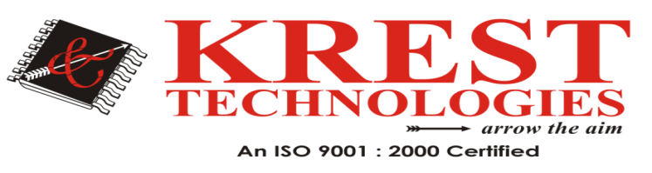

 | Artificial Intelligence and Machine Learning
1 | Identifying Regional Trends in Avatar Customization | 2018
2 | PCCA: Position Confidentiality Conserving Algorithm for Content-Protection in e-Governance Services and Applications | 2018
3 | DeepClue: Visual Interpretation of Text-based Deep Stock Prediction | 2018
4 | Improving Deep Learning Performance Using Random Forest HTM Cortical Learning Algorithm | 2018

HeadOffice: #202 2nd Floor, Pancom Business Center Opp, Chennai Shopping Mall, Ameerpet, Hyderabad 040-44433434 Mail-id: ramu.krest@gmail.com,www.kresttechnology.com
Branches: Dilsukhnagar (9000404181), Warangal (9000739460), Vijayawada (9000404182)

